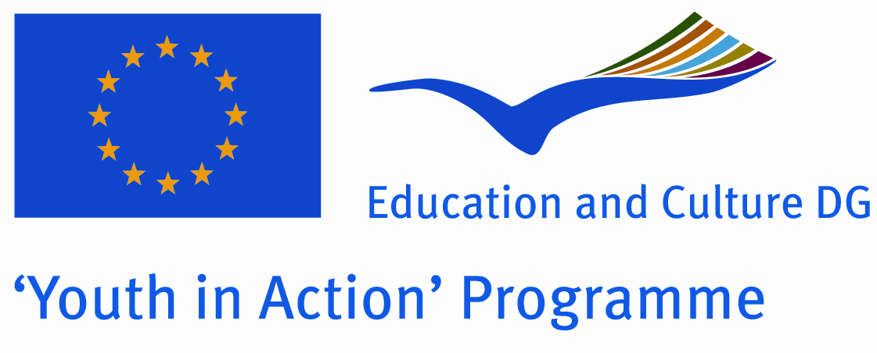 | Application for:  Action 1 - Youth for Europe  Sub-Action 1.1 - Youth Exchanges

“Traditions define you!”
25 – 31 ^{h} July, 2011
Maramures, Roumania

Please contact directly to;
proiecte@ghiziiromaniei.ro

ATGR Description: Romania’s Tourist Guides Association was founded in 2007 and its main objectives are environmental protection, promotion of ecotourism and eco culture, sports as healthy lifestyle. Members are young persons, who have that desire to create a better future in a clean environment.
ATGR has developed a series of projects among which: planting trees (3000 trees planted in 2009), waste collection in different mountain ranges and green spaces in major cities (8 tons in 2008, 10 tons in 2009, Mountain School (an educational program for young people to the fourth edition, designed to inspire them a civic and environmental conduct), Montaniada - mobilizing youth! (an event now in its third edition, which brings together young lovers of the mountain and of nature, and gives them the chance to exchange experience by participating at team mountain games. This year (2010) the event gathered more than 1,000 young people, and the number of participants is increasing year by year). We also organized sport and outdoor activities for young people in a park of the city. The scope of the project was to promote amoung teenagers outdoor activities even if they are done in urban space.
ATGR is affiliated with the Romanian Federation of Tourism and Ecology (FRTE) and participates annually in environmental protection projects and programs initiated by it.
At the Mountain School participate each year about 200 of the 500 students initially enrolled. They are trained by qualified persons in tourism, guiding, first aid, environmental protection.
We have experience in managing large groups of people, especially youngsters, knowing psycho-pedagogical characteristics and age specific issue which the young people nowadays are facing with.
ATGR has experience in environmentall issues. The organizations is actively implicated in promoting amoung young people an eco-civic attitude, ecotourism, sustanaiblity development and at the same time a healthy condition through outdoor activities.

Project summary: This project represents a multilateral youth exchange whose main objective is to discover the beauty of European countries traditions. These traditions are part of our country’s spirit, they represent us and they have been passed down for ages to young people like us so now is our pleasure to share it with young people from other European countries. It is necessary that the young generation learns the importance of preserving these traditions, so that we protect the ‘’past” of our country, and also its the “future” by teaching our children the value of traditions.
The activity will take place in Romania, Maramures County. The participants will present their specific traditions and they will also be involved in different activities such as : visiting prestigious monuments, monasteries, museums, admiring the beautiful landscapes in Maramures. Traditional activities of our country such as folk dancing, traditional foods, musical instruments will entertain them during their stay. During the project, the youngsters will have the opportunity to discover the cultural diversity of each European country and to maintain active and prolific debates with each other. This meeting will be only the beginning of our exchange program and into the future we will look deeply towards learning more information of other countries in Europe.

Date and venu: 25-31th July, 2011, Maramures, Romania

Target group: Non-Governmental organizations

Participants: 5 people for each cauntry. Totally 7 cauntries.

Working language: English

Haw to apply : Please send Part III froms to: 0040 21 32 32 566 by fax.
Original send via regular post to this address please:
Str. Agricultori, nr.109, sector 2, Bucuresti
Cod. Postal: 021485

Dedline for application: until 26th January 2011.

P.S: If you have proposition for the traditions theme that could be approached during the activities, we are open.

